Program Design
( Flow Chart and Block Diagram )

Team B

Dong-Eui University
Lee Sang-mok (Electrical Engineering)
Lee Jun-young (Computer Engineering)
Han Chang-hoon (Game Engineering)
Nam Jeong-hoon (Application Software Engineering)
You Gang-chon (Software Engineering)

Table of contents
Program Design 1
Table of contents 2
System Architect 6
System Reference Model 7
System Architecture 8
ER Diagram 9
Flow Chart 10
User Management 11
Sign Up (App/Web) 11
Sign In (App) 12
Sign In (Web) 13
Sign Out (App) 14
Sign Out (Web) 15
Provide Temporary Password (App/Web) 16
Change Password (App) 17
Change Password (Web) 18
Sign In Cancellation (App) 19
Data Measurement 20
Real Time Air Pollution Data Display/Transfer (App) 20
Real Time Air Pollution Data Display (Web) 21
Real Time Heart Rate Data Display/Transfer (App) 22
Real Time Heart Rate Data Display (Web) 23
Historical Air Pollution Data Transfer (App) 24
Historical Heart Rate Data Transfer (App) 25
Historical Air Pollution Data Display (App) 26
Historical Air Pollution Data Display (Web) 27
Historical Heart Rate Data Display (App) 28
Historical Heart Rate Data Display (Web) 29
Block Diagram 30
User Management 31
Sign Up Client (App) 31
Sign Up Client (Web) 32
Check User Information In Sign Up Client 33
Sign Up Server (App) 34
Sign Up Server (Web) 35
Check User Information In Sign Up Server 36
Sign In Client (App) 37
Sign In Client (Web) 38
Sign In Server (App) 39
Sign In Server (Web) 40
Sign Out Client (App) 41
Sign Out Client (Web) 42
Sign Out Server (App) 43
Sign Out Server (Web) 44
Provide Temporary Password Client (App) 45
Provide Temporary Password Client (Web) 46
Provide Temporary Password Server (App) 47
Provide Temporary Password Server (Web) 48
Change Password Client (App) 49
Change Password Client (Web) 50
Check Password In Change Password Client 51
Change Password Server (App) 52
Change Password Server (Web) 53
ID Cancellation Client (App) 54
ID Cancellation Server (App) 55
Data Measurement 56
Sensor Main Thread 56
Sensor Collect Data And Send Real Time Data Tread 57
Sensor Send Historical Data Tread 58
Real Time Air Pollution Data Transfer Client (Sensor) 59
Real Time Air Pollution Data Transfer and Display Client (App) 60
Real Time Air Pollution Data Transfer Server (App) 61
Real Time Air Pollution Data Display Client (Web) 62
Real Time Air Pollution Data Display Server (Web) 63
Real Time Heart Rate Data Transfer and Display Client (App) 64
Real Time Heart Rate Data Transfer Server (App) 65
Real Time Heart Rate Data Display Client (Web) 66
Real Time Heart Rate Data Display Server (Web) 67
Historical Air Pollution Data Transfer Client (Sensor) 68
Historical Air Pollution Data Transfer Client receive from sensor (App) 69
Historical Air Pollution Data Transfer Client (App) 70
Historical Air Pollution Data Transfer Server (App) 71
Historical Air Pollution Data Display Client (App) 72
Historical Air Pollution Data Display Client (Web) 73
Historical Air Pollution Data Display Server (App) 74
Historical Air Pollution Data Display Server (Web) 75
Historical Heart Rate Data Transfer Client (App) 76
Historical Heart Rate Data Transfer Server (App) 77
Historical Heart Rate Data Display Client (App) 78
Historical Heart Rate Data Display Client (Web) 79
Historical Heart Rate Data Display Server (App) 80
Historical Heart Rate Data Display Server (Web) 81

System Architect

System Reference Model

System Architecture

ER Diagram
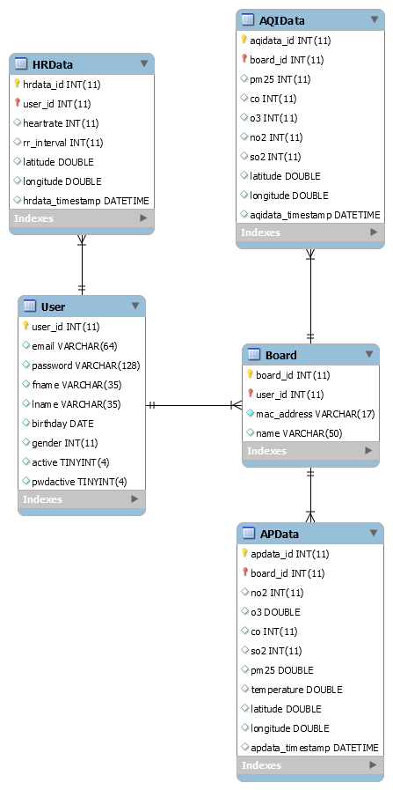

Flow Chart

User Management

Sign Up (App/Web)

Sign In (App)

Sign In (Web)

Sign Out (App)

Sign Out (Web)

Provide Temporary Password (App/Web)

Change Password (App)

Change Password (Web)

Sign In Cancellation (App)

Data Measurement

Real Time Air Pollution Data Display/Transfer (App)

Real Time Air Pollution Data Display (Web)

Real Time Heart Rate Data Display/Transfer (App)

Real Time Heart Rate Data Display (Web)

Historical Air Pollution Data Transfer (App)

Historical Heart Rate Data Transfer (App)

Historical Air Pollution Data Display (App)

Historical Air Pollution Data Display (Web)

Historical Heart Rate Data Display (App)

Historical Heart Rate Data Display (Web)

\

Block Diagram

User Management

Sign Up Client (App)

Sign Up Client (Web)

Check User Information In Sign Up Client

Sign Up Server (App)

Sign Up Server (Web)

Check User Information In Sign Up Server

Sign In Client (App)

Sign In Client (Web)

Sign In Server (App)

Sign In Server (Web)

Sign Out Client (App)

Sign Out Client (Web)

Sign Out Server (App)

Sign Out Server (Web)

Provide Temporary Password Client (App)

Provide Temporary Password Client (Web)

Provide Temporary Password Server (App)

Provide Temporary Password Server (Web)

Change Password Client (App)

Change Password Client (Web)

Check Password In Change Password Client

Change Password Server (App)

Change Password Server (Web)

ID Cancellation Client (App)

ID Cancellation Server (App)

Data Measurement

Sensor Main Thread

Sensor Collect Data And Send Real Time Data Tread

Sensor Send Historical Data Tread

Real Time Air Pollution Data Transfer Client (Sensor)

Real Time Air Pollution Data Transfer and Display Client (App)

Real Time Air Pollution Data Transfer Server (App)

Real Time Air Pollution Data Display Client (Web)

Real Time Air Pollution Data Display Server (Web)

Real Time Heart Rate Data Transfer and Display Client (App)

Real Time Heart Rate Data Transfer Server (App)

Real Time Heart Rate Data Display Client (Web)

Real Time Heart Rate Data Display Server (Web)

Historical Air Pollution Data Transfer Client (Sensor)

Historical Air Pollution Data Transfer Client receive from sensor (App)

Historical Air Pollution Data Transfer Client (App)

Historical Air Pollution Data Transfer Server (App)

Historical Air Pollution Data Display Client (App)

Historical Air Pollution Data Display Client (Web)

Historical Air Pollution Data Display Server (App)

Historical Air Pollution Data Display Server (Web)

Historical Heart Rate Data Transfer Client (App)

Historical Heart Rate Data Transfer Server (App)

Historical Heart Rate Data Display Client (App)

Historical Heart Rate Data Display Client (Web)

Historical Heart Rate Data Display Server (App)

Historical Heart Rate Data Display Server (Web)

